Life in Boka now

Today, The Bay of Boka is still one of the most beautiful bays in the world.
Many things are different today. The towns and houses in Boka are bigger and more beautiful than they used to be. Lately, houses and buildings are made of bricks and concrete bloks. People live in them permanently but there are also a lot of apartments that are made for rent. That's why Boka, now, has a lot more people than it used to have before.
The main occupation of the inhabitants of Boka is a tourism. A lot of people work in hotels, restaurants and have their own villas to rent. The position of women is different now than it was in the past. They mostly have their jobs. Duties in the family are equal between men and woman. People in Boka still eat traditional food: fish, fruits, vegetables. Also, fast food is very popular.
There are many more cars than before on the streets. The main way of transport is a car. The traffic is crowded. There’s no more train called “Ćiro”. Boka’s towns are connected by buses. In their free time people usually go to each other and have fun together, making barbeque or go to the trips in the mountains. Some people have their own boats and go fishing. Children usually play video games, ride bikes, play football or basketball.
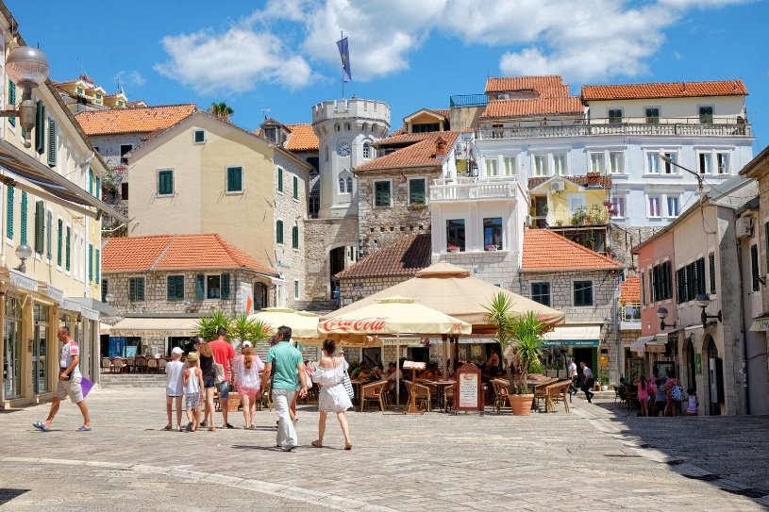
Herceg Novi before Herceg Novi today

