Riješi zadatak:

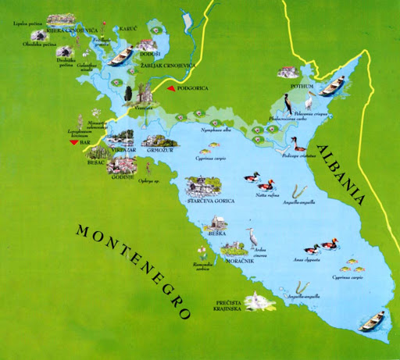Ako znaš da je maksimalna dužina Skadarskog jezera 40 km , širina 14 km, dubina 44m izracunaj približnu zapreminu jezera. Posmatraj sliku!

Sastavi zadatak vezan za zapreminu tijela koristeći pojmove: Crno jezero, ekolozi, otpad, kontejneri u obliku kvadra, 1/3.

_________________________________________________________________________________________________________________________________________________________________________________________________________________________________________________________________________________________________________________________________________________________________________________________________________________________________________